【Product display and Introduction】
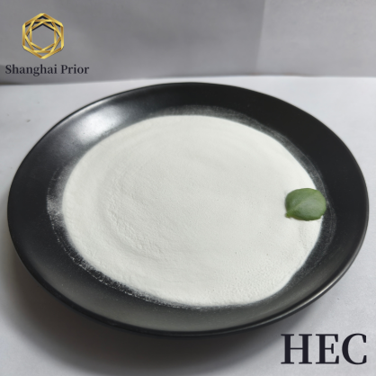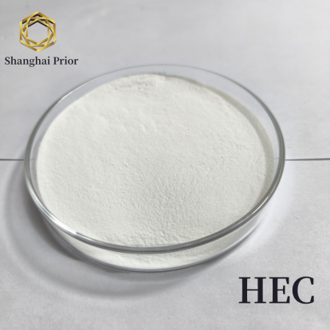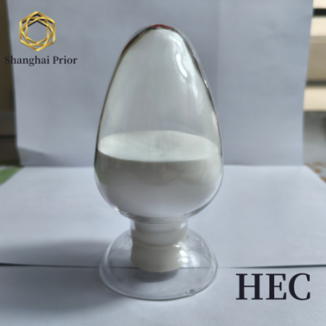
Hydroxyethyl Cellulose is made from natural polymer cellulose, is non-ionic water-soluble polymer, it is yellowish or white, odorless and tasteless powdered solid.
Hydroxyethyl Cellulose is non-ionic water-soluble polymer, it is effective in thickening, bonding, emulsifying, dispersing, stabilizing and water preserving, forming film and providing protective colloid effect in such industries like architectural coating, petroleum and daily-use chemicals. Hydroxyethyl Cellulose is very easily soluble not only in cold water, but also in hot water, and can provide solutions with wider range of viscosity..
【Product models and standards: 】
Item | Details
Appearance | yellowish or white odorless and tasteless granular powder.
Viscosity | See viscosity specification sheet
Moisture, % ≤ | 5
Ash, % ≤ | 5
pH (1%, solution) | 6～8.5

Viscosity specification code sheet（25℃, LVD）
Viscosity specification | Viscosity range（1%），mpa.s | Viscosity range（2%），mpa.s | Viscosity range（5%），mpa.s | Rotor number | Rotate speed，rpm
09 |  |  | 75-150 | 1 | 30
3 | / |  | 150-400 | 2 | 60
40 |  | 25-105 |  | 1 | 30
300 | / | 150-400 |  | 2 | 30
2000 | / | 1500-2500 |  | 3 | 30
6000 | / | 4500-6500 |  | 4 | 60
15000 | 700-1500 |  |  | 3 | 30
30000 | 1500-2400 |  |  | 3 | 30
50000 | 2400-3300 |  |  | 3 | 30
100000 | 3300-6000 |  |  | 4 | 30
Attention: The above viscosity values are all obtained using Brookfield Viscometer at 25℃, LVD.

[Product applications]
Latex paint
HEC is the most commonly used thickener in Latex painting. In addition to thickening to the latex paint, it has functions of emulsifying, dispersing, stabilizing and water-retaining. It is characterized by the significant thickening effect, excellent color development, film forming and storage stability.
Oil drilling
In oil drilling industry, high-viscosity HEC is mainly used as thickener in completion and finishing fluid; while low-viscosity HEC is mainly used as water loss controller. HEC used as thickener will impart good mobility and stability to various slurries necessary for drilling, completion, cementing and fracturing operations. In drilling,
Daily-use chemical industry
In shampoo, hair spray, neutralizer, conditioner and cosmetics, HEC is an effective film former, binder, thickener, stabilizer and disperser. In powder detergent, it is a dirt anti-deposition agent. The detergent containing HEC has the unique feature of improving smoothness and silkiness of the fabrics.
Paper and Printing Ink
HEC can be used as a sizing agent on paper and paperboard and as a thickener and suspending agent for water-based inks.
Construction
Used in construction formulations such as concrete mixture, fresh mortar, gypsum plaster or clay, HEC acts as a water retaining agent during applying prior to solidifying of these compositions. Beside improving the water retention of construction formulations, HEC could also extend the open and trowelling time of plaster or clay and reduce occurrence of crusting, slipping and sagging, thus improving the work ability and efficiency and saving time, and meanwhile, raising the compatibilization rate of plaster, thus saving raw materials.

【Packaging&Note】
N.W.: 25±0.25kg / package
Inner: Polyethylene plastic film bag
Outer: Three-in-one composite paper bag or barrel

Keep away from rain, sunshine and hook during transportation.
Store in a ventilated/dry place, avoid moisture, don’t store together with other chemicals.
Easy to absorb moisture. Please seal and pack after opening and store in a dry place.

